The kill switch will get activated at low inorganic phosphate (Pi) concentration. Pi concentration is high in the small intestine (0.5-17.5 mM)1 and in standard wastewater, Pi concentration is around 5 mg/L (approximately 53μM) 2. While going through literature, we came across a research paper in which a control model was developed for the Pho regulon and it was fit into experimental data to obtain the parameters corresponding to a particular external Pi concentration (Pex). Here, the plots were fit into data corresponding to 200μM and 50μM. As it is experimentally proven that the expression always decreases with increase in Pext, it would be valid to say that if the kill switch is inactive at 200μM, it will be inactive at higher concentration. Two different approaches for the kill switch are modelled here. The experimental data in (2) which was used to fit the control models was when pPhoA was cloned in a low copy number plasmid ( approximately 20). Assuming that the transcription rate is in a linear relationship with the copy number, we have multiplied the transcription rates of the promoters of the toxin and antitoxin by 20 so that the relative amount will be the same, because the model developed here is for chromosomal insert of the probiotic. Although by qualitative analysis of the Pho regulon system, we can say that the amount obtained by linear correlation would be an underestimation3.

**Variables for the control model**

|  |  |
| --- | --- |
| **Variable** | **Description** |
| [DR] | Concentration of dimerised PhoR |
| [DRp] | Concentration of dimerised singly phosphorylated PhoR |
| [DRpp] | Concentration of doubly phosphorylated PhoR |
| [DRpB] | Concentration of singly phosphorylated DiPhoR and PhoB complex |
| [DRppB] | Concentration of doubly phosphorylated DiPhoR and PhoB complex |
| [B] | Concentration of PhoB |
| [Bp] | Concentration of phosphorylated PhoB |
| [DRBp] | Concentration of phosphorylated PhoB and DiPhoR complex |
| [DBpp] | Concentration of dimerised phosphorylated PhoB |
| [pA] | Concentration of pPhoA |
| [pAa] | Concentration of activated pPhoA |
| [pB] | Concentration of pPhoB |
| [pBa] | Concentration of activated pPhoB |
| Ma | Concentration of mRNAa |
| Mb | Concentration of mRNA of PhoB |
| P | Concentration of the protein downstream of pPhoA |

**Reactions of the control model (click Tab)**

1. 
2. 
3. 
4. 
5. 
6. 
7. 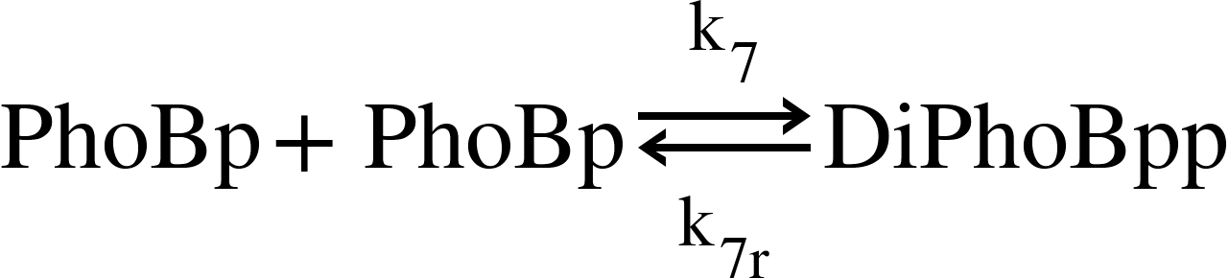
8. 
9. 
10. 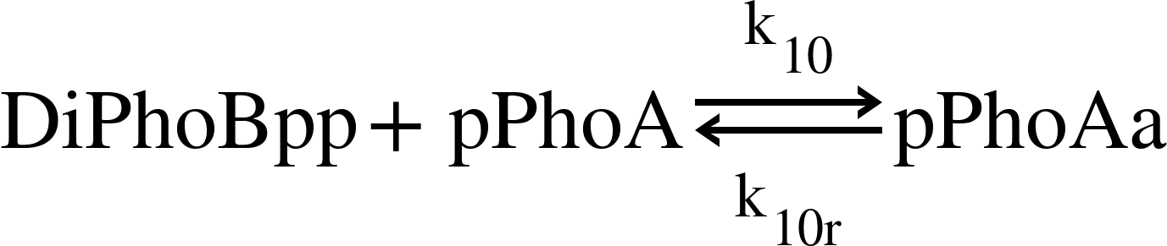
11. 
12. 
13. 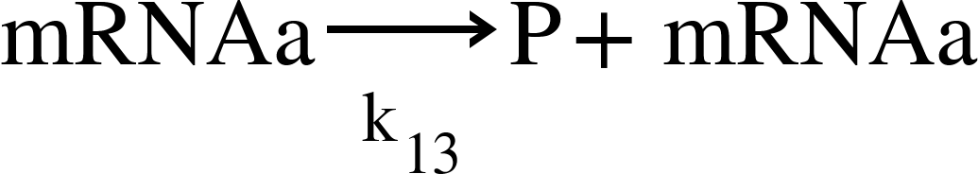
14. 
15. 
16. 
17. 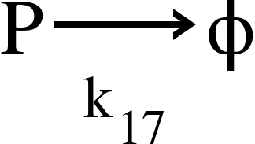
18. 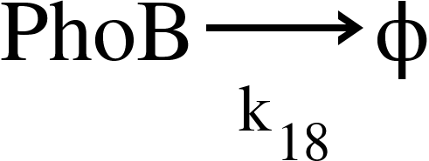
19. 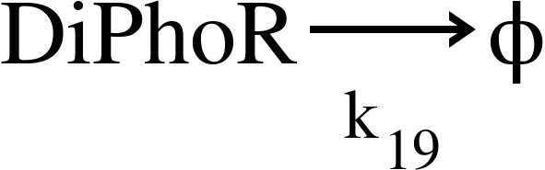
20. 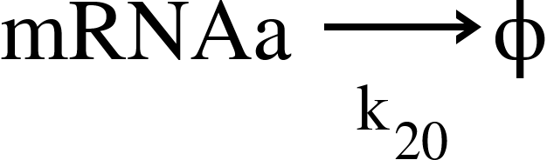
21. 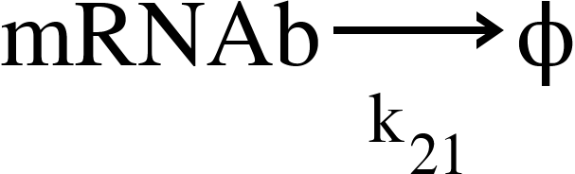

Differential equations for the control model

1. 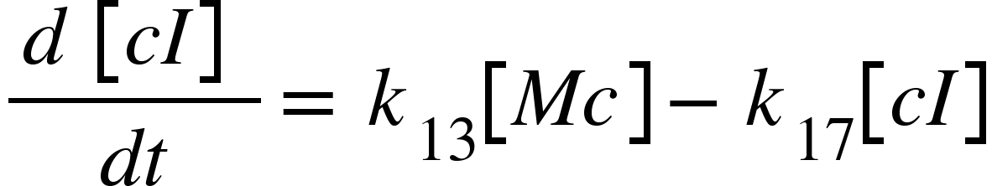
2. 
3. 
4. 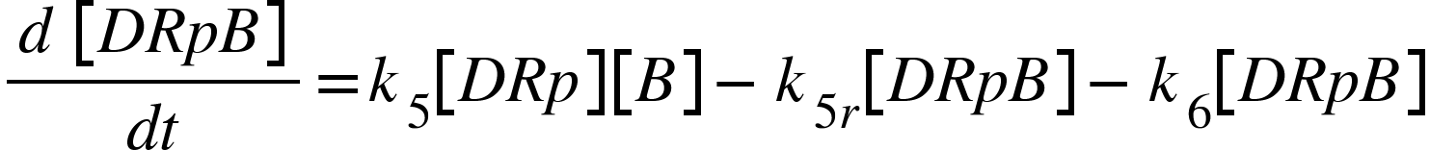
5. 
6. 
7. 
8. 
9. 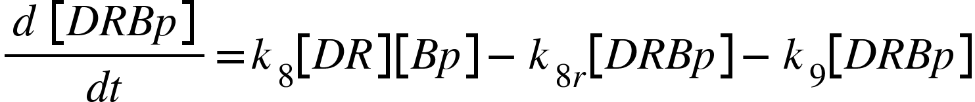
10. 
11. 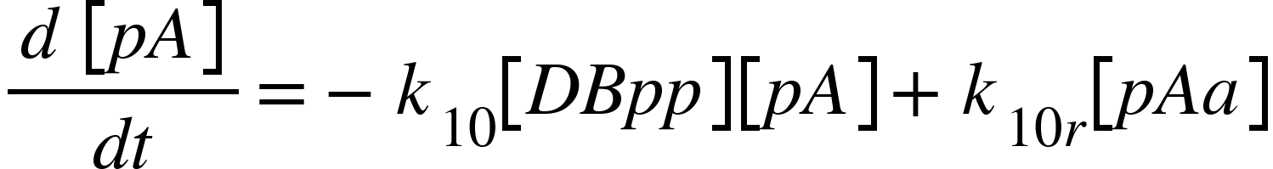
12. 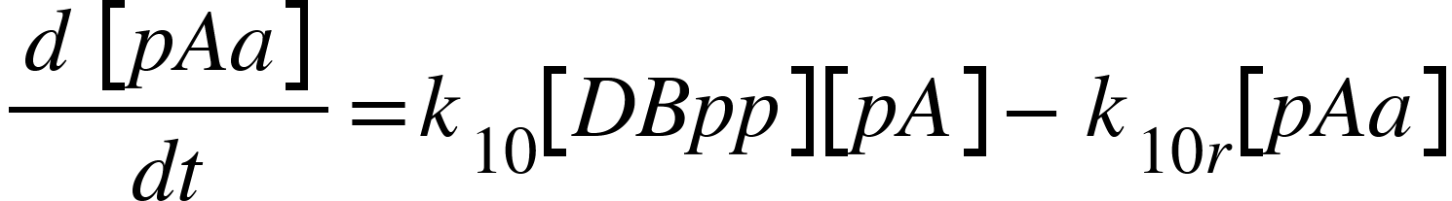
13. 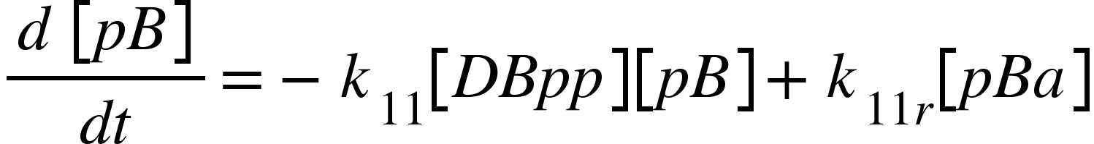
14. 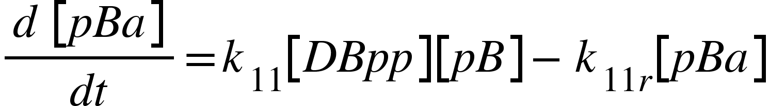
15. 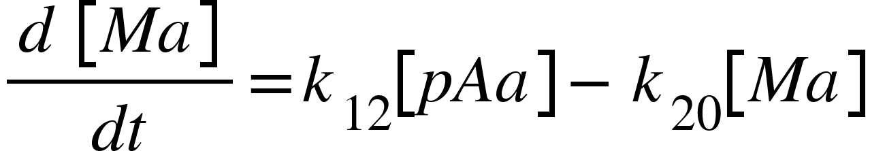
16. 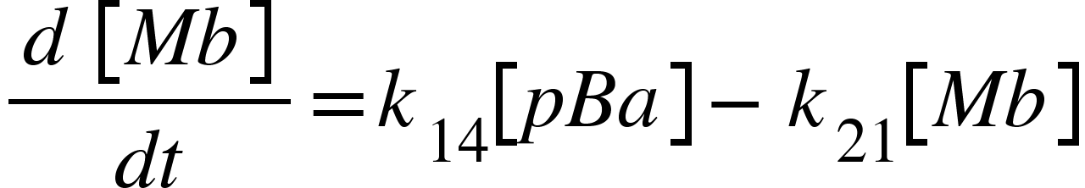

**Parameters for the control model**

As the parameters were obtained by fitting experimental data into the control model, $k_{14}$ and $k_{12}$ are varied to fit the final protein concentration corresponding to a particular Pext. After contacting one of the authors of (2), we were able to obtain the values of $k_{14}$ and $k_{12}$ corresponding to Pext=200μM and 50μM ($k_{14}$ = $k_{12}$ = 0 and 0.023 s-1 respectively).

|  |  |  |  |  |
| --- | --- | --- | --- | --- |
| **Reaction N.** | **Rate** | **Parameter value** | **Description** | **Reference** |
| 1 | $k_{1}$ | 25.3658 1/s | Rate of DiPhoR phosphorylation | (2) |
| 1 reverse | $k_{1r}$ | 8.1165 1/s | Rate of DiPhoR dephosphorylation | (2) |
| 2 | $k_{2}$ | 23.3658 1/s | Rate of DiPhoRp phosphorylation | (2) |
| 2 reverse | $k_{2r}$ | 8.1165 1/s | Rate of DiPhoRpp dephosphorylation | (2) |
| 3 | $k_{3}$ | 100 1/μMs | Rate of DiPhoRpp and PhoB complex formation | (2) |
| 3 reverse | $k_{3r}$ | 74.9411 1/s | Rate of dissociation of DiPhoRpp and PhoB complex | (2) |
| 4 | $k_{4}$ | 21.3718 1/s | Rate of phosphoryl transfer from DiPhoRpp to PhoB | (2) |
| 5 | $k_{5}$ | 100 1/μMs | Rate of DiPhoRp and PhoB complex formation | (2) |
| 5 reverse | $k_{5r}$ | 74.9411 1/s | Rate of dissociation of DiPhoRp and PhoB complex | (2) |
| 6 | $k_{6}$ | 21.3718 1/s | Rate of phosphoryl transfer from DiPhoRp to PhoB | (2) |
| 7 | $k_{7}$ | 100 1/μMs | Rate of dimerisation of PhoBp | (2) |
| 7 reverse | $k_{7r}$ | 74.9411 1/s | Rate of dissociation of PhoBp dimer | (2) |
| 8 | $k_{8}$ | 100 1/μMs | Rate of DiPhoR and PhoBp complex formation | (2) |
| 8 reverse | $k_{8r}$ | 74.9411 1/s | Rate of dissociation of DiPhoR and PhoBp complex | (2) |
| 9 | $k_{9}$ | 12.95 1/s | Rate of Phosphatase activity | (2) |
| 10 | $k_{10}$ | 10000 1/μMs | Rate of activation of pPhoA | (2) |
| 10 reverse | $k_{10r}$ | 1000 1/s | Rate of deactivation of pPhoA | (2) |
| 11 | $k_{11}$ | 10000 1/μMs | Rate of activation of pPhoB | (2) |
| 11 reverse | $k_{11r}$ | 1000 1/s | Rate of deactivation of pPhoB | (2) |
| 12 | $k_{12}$ | 0.0510 1/s | Rate of transcription of mRNAa | (2) |
| 13 | $k_{13}$ | 0.0302 1/s | Rate of translation of the protein coded by mRNAa | (2) |
| 14 | $k_{14}$ | 0.510 1/s | Rate of transcription of mRNAb | (2) |
| 15 | $k_{15}$ | 0.0302 1/s | Rate of translation of PhoB | (2) |
| 16 | $k_{16}$ | 0.0302 1/ s | Rate of translation of DiPhoR | (2) |
| 17 | $k_{17}$ | 0.0001 1/s | Rate of degradation of protein P | (2) |
| 18 | $k_{18}$ | 0.0001 1/s | Rate of degradation of PhoB | (2) |
| 19 | $k_{19}$ | 0.0001 1/s | Rate of degradation of DiPhoR | (2) |

**Variables for the Toxin-Antitoxin system**

|  |  |
| --- | --- |
| **Variable** | **Description** |
| [Ma] | Concentration of antisense RNA |
| [Mi] | Concentration of IM2 mRNA |
| [Me] | Concentration of E2 mRNA |
| [I] | Concentration of IM2 that is not bound to E2 |
| [E] | Concentration of E2 that is not bound to IM2 |
| [Mai] | Concentration of antisense RNA-mRNA complex |
| [D] | Concentration of IM2-E2 dimer |
| [cI] | Concentration of repressor |

**Case I**

Our initial approach was to express an antisense RNA complementary to mRNA of IM2, so that it will get repressed at lower Pi concentrations. Hence increasing the activity of the toxin.

**Differential equations:-**

So,

d[Ma]/dt becomes,



Also,

1. 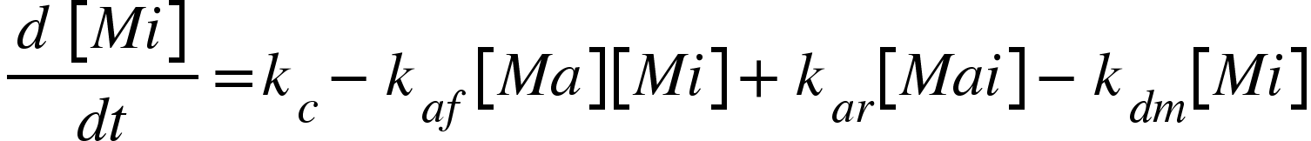
2. 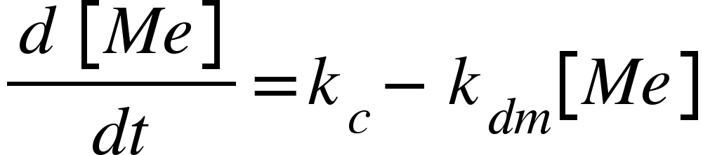
3. 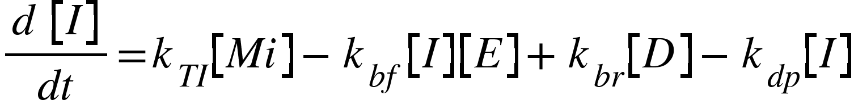
4. 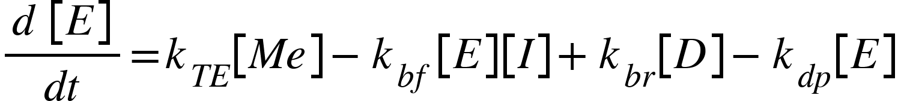
5. 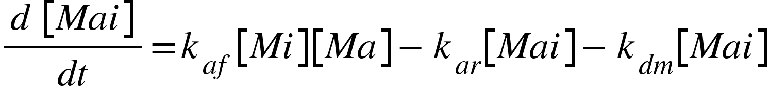
6. 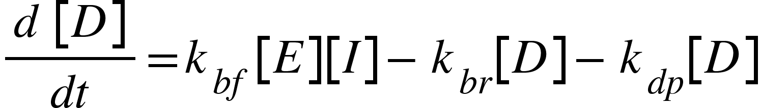

The ODEs were solved and plots were generated using Wolfram Mathematica.

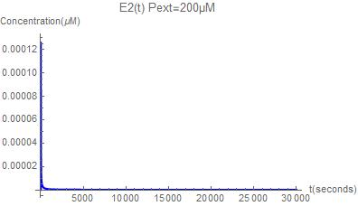



Figure 1: Concentration of E2 vs time graph for the antisense RNA based kill switch

As we can observe from this graph, the toxin concentration is not increasing and hence this kill switch is predicted to be ineffective at 50μM and 200μM concentration. But for our system, the kill switch should be activated at 50μM.

**Case II**

Downstream of PphoA, cI protein is expressed (Hence, [cI]=[A]). cI will act as a repressor for the constitutively active promoter cIlam after dimerisation. cIlam will be expressing the antitoxin (IM2) which will form a complex with the toxin (E2) which is being expressed using a constitutively active promoter (BBa_J23100) thereby repressing its activity. At lower Pi concentrations, cI will be expressed hence repressing the antitoxin. This will cause the concentration of the toxin to increase, hence promoting it’s DNase activity.

Equations:-

1. 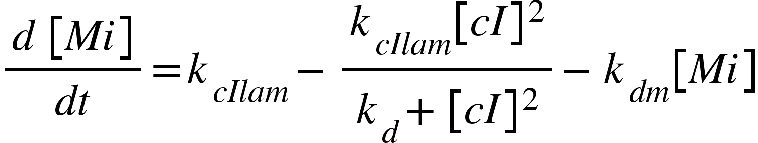
2. 
3. 
4. 
5. 

The ODEs were solved and plots were generated using Wolfram Mathematica

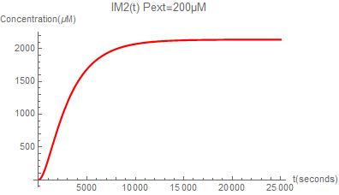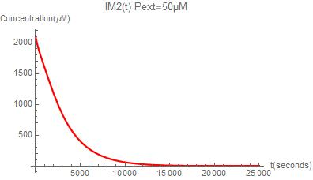

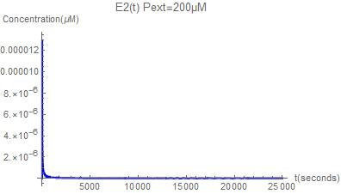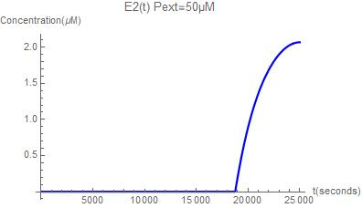

Figure 2: Concentration of E2 and IM2 vs time graph for the repressor based kill switch

For optimising the kill switch for better results, Minicolicin ([BBa_K1976027](http://parts.igem.org/Part:BBa_K1976027)) (134 aa) which is the DNAse domain of E2 is a good alternative as it is a protein with much less molecular weight compared to E2 and thus has a higher rate of translation. As the complex formation with IM2 is also done via the DNAse domain and this domain alone has a very high binding affinity4, at lower concentration it's safe to assume that at lower ( μMs and mMs) the binding kinetics is similar to that between IM2 (86 aa) and E2 (581 aa).

In the case of minicolicin (miniE2), = 0.127 s-1

Therefore plots are generated in the case of miniE2,

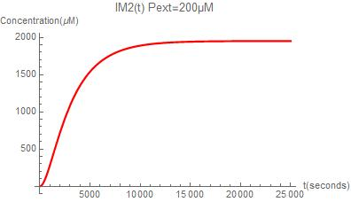 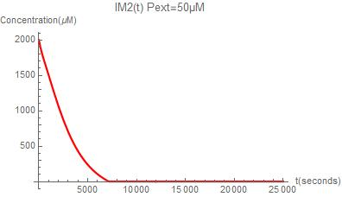

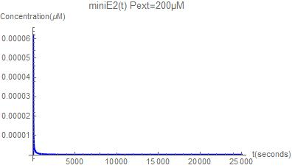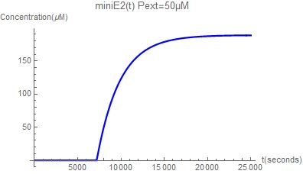

Figure 3: Concentration of miniE2 and IM2 vs time graph for the repressor based kill switch

From Figure 2 and 3, we can say that the kill switch containing miniE2 instead of E2 activates faster and the toxin increases at a higher rate. One should also note that the time difference in activation predicted in this model is an underestimation as the transcription rate of the miniE2 mRNA is also less compared to E2. Even Though we could not quantify the exact difference, this proves the point that using minicolicin (miniE2) would give a better result.

Parameter values for the toxin-antitoxin system

|  |  |  |  |  |
| --- | --- | --- | --- | --- |
| Sl No. | Parameter | Parameter value | Description | Reference |
| 21 |  | 10-14 μM | Rate of dissociation of antisense RNA-mRNA complex | Assumed for best case scenario |
| 2 |  | 520 μM-1s-1 | Rate of formation of Toxin-Antitoxin complex | (6) |
| 3 |  | 2 X 10-6 s-1 | Rate of dissociation of Toxin-Antitoxin complex | (6) |
| 4 | $k_{cIlam}$ | 0.00275 μM-1s-1 | Maximal transcription rate of cIlam | (7) |
| 5 | $k_{c}$ | 0.000047μM-1s-1 | Transcription rate of the constitutively expressing promoter | (8) |
| 6 |  | 0.197s-1 | Translation rate of IM2 (86 aa) | Estimated from (5) |
| 7 |  | 0.029s-1 | Translation rate of E2 (581 aa) | Estimated from (5) |
| 8 | $k_{d}$ | 0.002μM | Dissociation constant of cI with cIlam | (7) |
| 9 | $k_{dm}$ | 0.0013s-1 | mRNA degradation rate | (9) |
| 10 | $k_{dp}$ | 0.00038 | Protein degradation rate | (10) |

**Conclusion**

As one can notice, the amount of antisense RNA produced predicted via this model is an underestimation and it would be difficult to predict it unless experimental studies are performed. There are considerable uncertainties in the parameters of this model. As we could not perform experiments, the purpose of this model was to predict which kill switch can be used more confidently even after incorporating all these uncertainties. From the predictions, we could predict that the repressor based kill switch (Case II) with minicolicin as the toxin gave more promising results compared to other approaches.

**References**

1. R Todd Alexander Intestinal phosphate absorption: The paracellular pathway predominates?[https://doi.org/10.1177/1535370219831220](https://doi.org/10.1177%2F1535370219831220)
2. <https://tspcb.cgg.gov.in/Environment/General%20Standards%20For%20Discharge%20Of%20Environmental%20Pollutants.pdf>
3. Van Dien, S. J. & Keasling, J. D. A dynamic model of the *Escherichia coli* phosphate-starvation response. *J. Theor. Biol* 190, 37–49 (1997)
4. C Kleanthous[**.**](https://www.rcsb.org/search?q=citation.rcsb_authors:Kleanthous,%20C.)Structure of the Ultra-High-Affinity Colicin E2 DNase-Im2 Complex.(2012) J Mol Biol **417**: 79-94
5. Bremer, H., and Dennis, P. P. (2008) Modulation of Chemical Composition and Other Parameters of the Cell at Different Exponential Growth Rates. *EcoSal Plus* 3.
6. C Kleanthous. (2004). *Highly Discriminating Protein–Protein Interaction Specificities in the Context of a Conserved Binding Energy Hotspot. Journal of Molecular Biology, 337(3), 743–759.* doi:10.1016/j.jmb.2004.02.005.
7. <https://2019.igem.org/Team:IISER-Pune-India/Model/regulatory>
8. <http://2016.igem.org/Team:Sydney_Australia/InternalCellular>
9. <https://bionumbers.hms.harvard.edu/bionumber.aspx?s=n&v=2&id=106253>
10. https://2018.igem.org/Team:Edinburgh_UG/Degradation_Switch